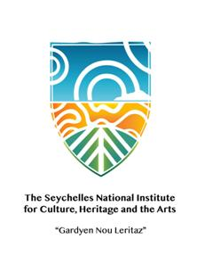

**SEYCHELLES NATIONAL HERITAGE RESOURCE COUNCIL**

**Expression of Interest**

**RENTAL OF KIOSK NO 8 AT DOMAINE VAL DES PRÈS, AU CAP.**

The Seychelles National Heritage Resource Council would like to invite all locally registered artist/Artisan to submit their interest for the rental of Kiosk No 8 (37.2 m2) at Domaine Val des Près, Au Cap for the sales of local Arts and Craft products.

**Submission of Expression of Interest**

All interested candidate should submit their interest to the **Chief Executive Officer**, Domaine Val des Près, Au Cap not later than **Friday 28th January 2022** in writing in a seal enveloped marked **RENTAL OF KIOSK NO 8 AT DOMAINE VAL DES PRÈS, AU CAP**

Interested partners should also submit the following documents along with their expression of interest

* Registration proof as local/Seychellois artisan/artist
* Proof of work through samples portfolio
* A project memorandum must be presented outlining the nature of work intended

Further information can be found in the terms of reference (TOR) which is available for collection at Seychelles National Heritage Resource Council at the Administration Section, Domaine de Val de Pres, Au cap as of **Thursday 20th January 2022** from **8a.m to 3.00p.m**. Deadline for the collection of TOR will be **Monday 24th January 2022 at 3.00pm**